10PEARLS
10Shine Internship Program

Assignment No. 5

Assignment No. 5 – API Testing with JMeter

Domain: Quality Assurance (Manual + Automation)

Submitted by: Muhammad Faizan Anwar
QA Intern – 10Shine Cohort

1. Executive Summary & Project Objectives
This report outlines the design, execution, and validation of a comprehensive API testing suite using Apache JMeter. The primary objective of this project was to bridge the gap between functional API testing and non-functional performance engineering. By automating a complete CRUD (Create, Read, Update, Delete) lifecycle and subjecting the system to a localized stress test, this suite validates both data integrity and system stability under load.
- Key Technical Milestones Achieved:
- Successfully parameterized test data using external CSV files for data-driven POST requests.
- Implemented API Chaining via JSON Extractors to dynamically pass generated object IDs across sequential endpoints.
- Deployed a localized REST API environment (JSON Server) to execute high-volume stress tests without violating public rate limits or compromising test validity through mock-API caching.

2. Architectural Approach & Environment Configuration

To ensure the JMeter test plan remained scalable and easily modifiable, global configuration elements were implemented at the Test Plan level.

- HTTP Request Defaults
Rather than hardcoding URLs into every sampler, the base configuration was centralized. Following the mitigation of external IP blocks, the target environment was shifted to a local deployment.
- Server Name/IP: localhost
- Port Number: 3000
- Protocol: http

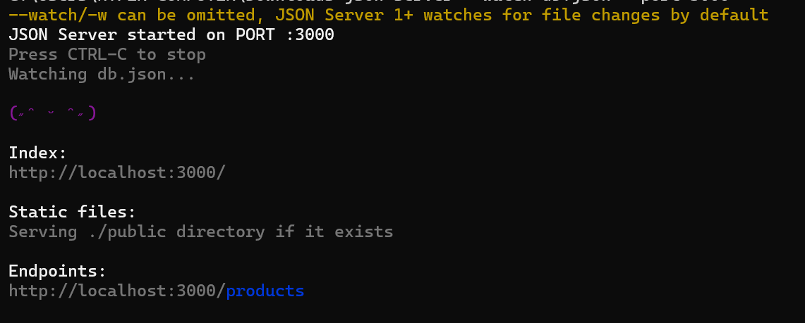

- HTTP Header Manager
Configured to automatically append the 'Content-Type: application/json' header to all outgoing requests, ensuring the server correctly parsed the dynamic payload bodies.

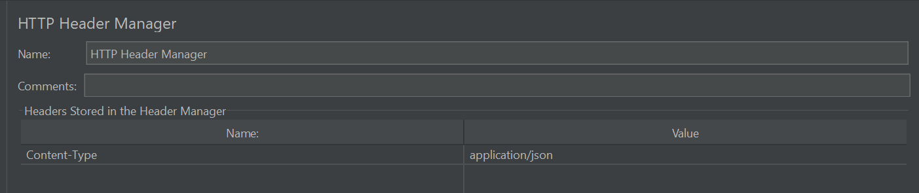

- CSV Data Set Config (Data-Driven Testing)
A CSV file (test_data.csv) was integrated to simulate unique user inputs. Variables such as ${productTitle} and ${productPrice} were injected dynamically into the HTTP Samplers to verify the system could handle varied data types and structures.

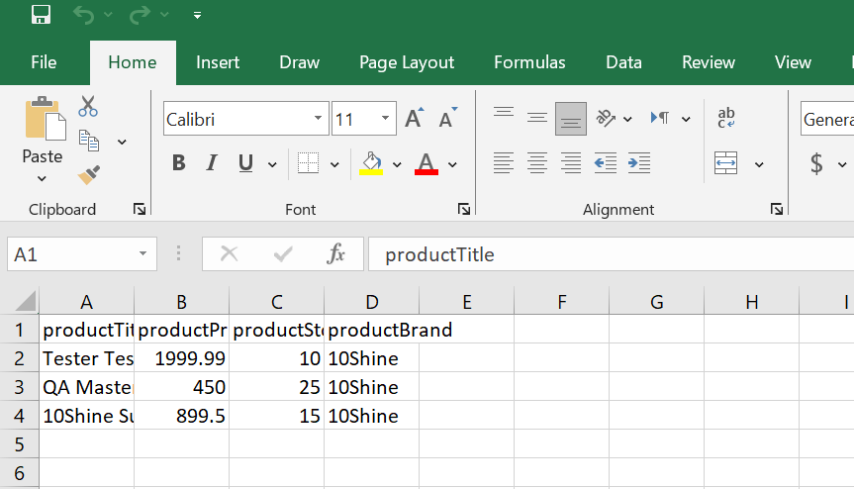

3. Functional Automation: The Complete CRUD Lifecycle
The functional testing phase (Thread Group: CRUD Load Test) simulates 3 concurrent users executing a strict sequential workflow. A Constant Timer of 400ms was applied to pace the thread execution.

Step 3.1: POST - Create Object
Objective: Inject CSV data to create a new database entry and extract its unique identifier for downstream testing.

Assertion Logic: A Response Assertion was configured to expect a 201 (Created) status code. Additionally, a JSON Extractor was applied to the response body (JSON Path: $.id) to capture and
save the generated ID into the variable ${extractedId}.

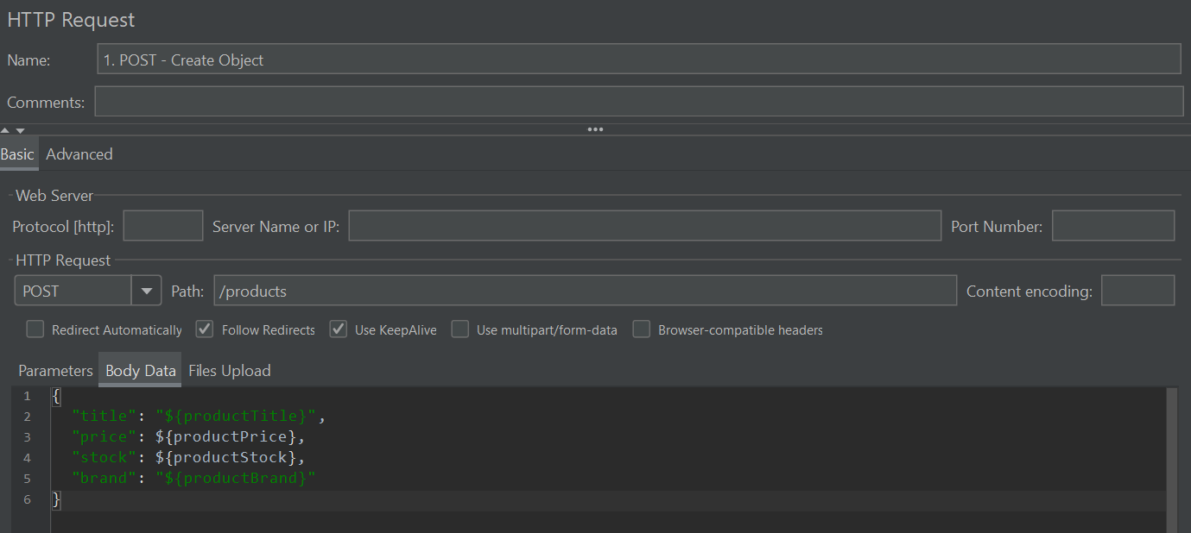
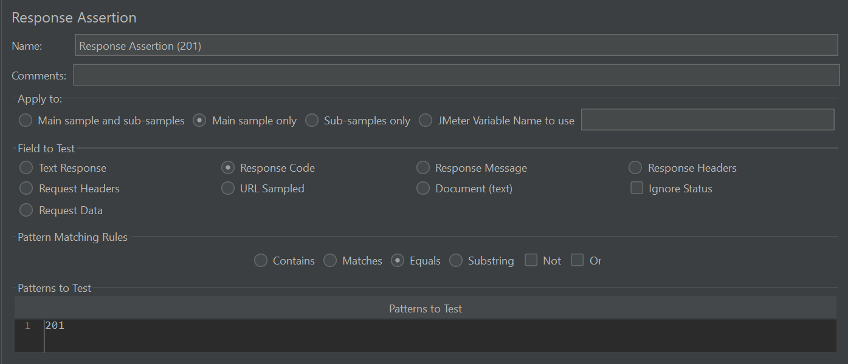
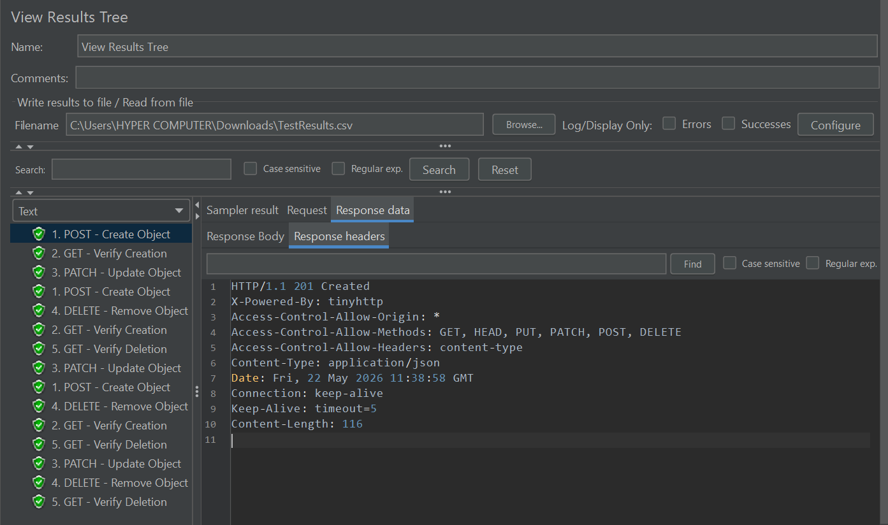

Step 3.2: GET - Verify Creation
Objective: Validate that the data submitted in Step 3.1 was physically written to the database and is retrievable.

Assertion Logic: Targets the endpoint /products/${extractedId}. Asserts a standard 200 OK HTTP Response Code to verify successful retrieval.

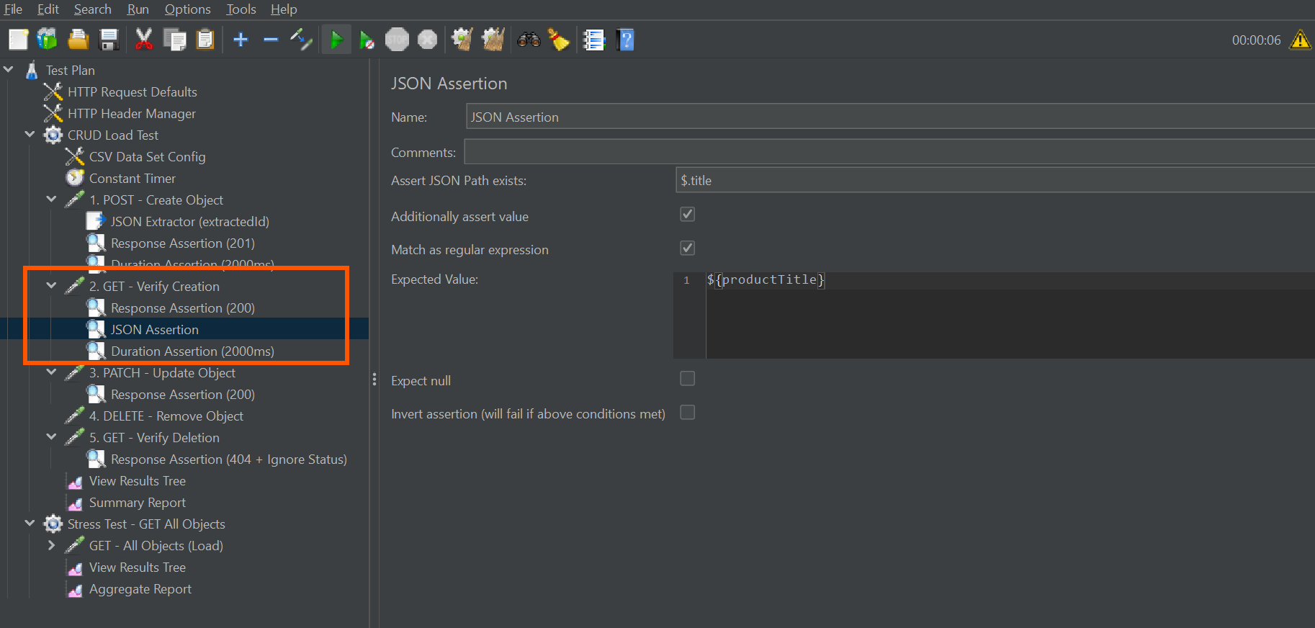

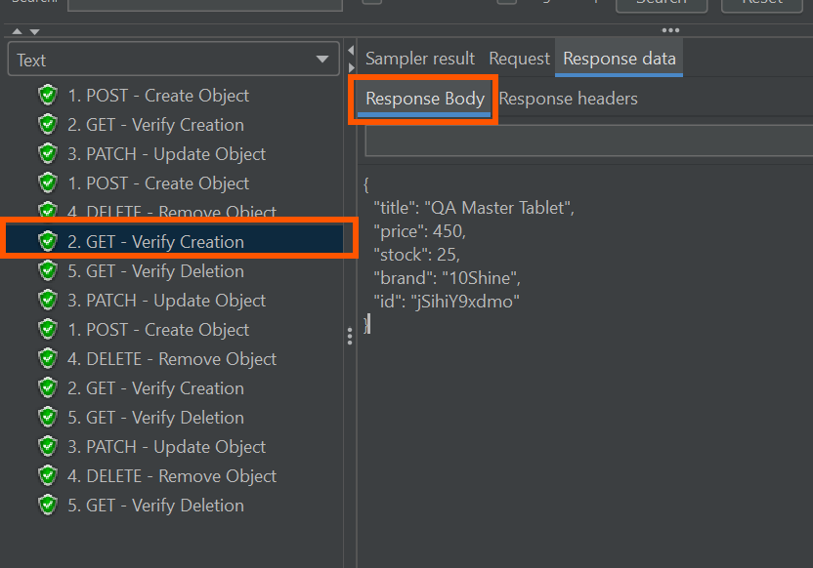
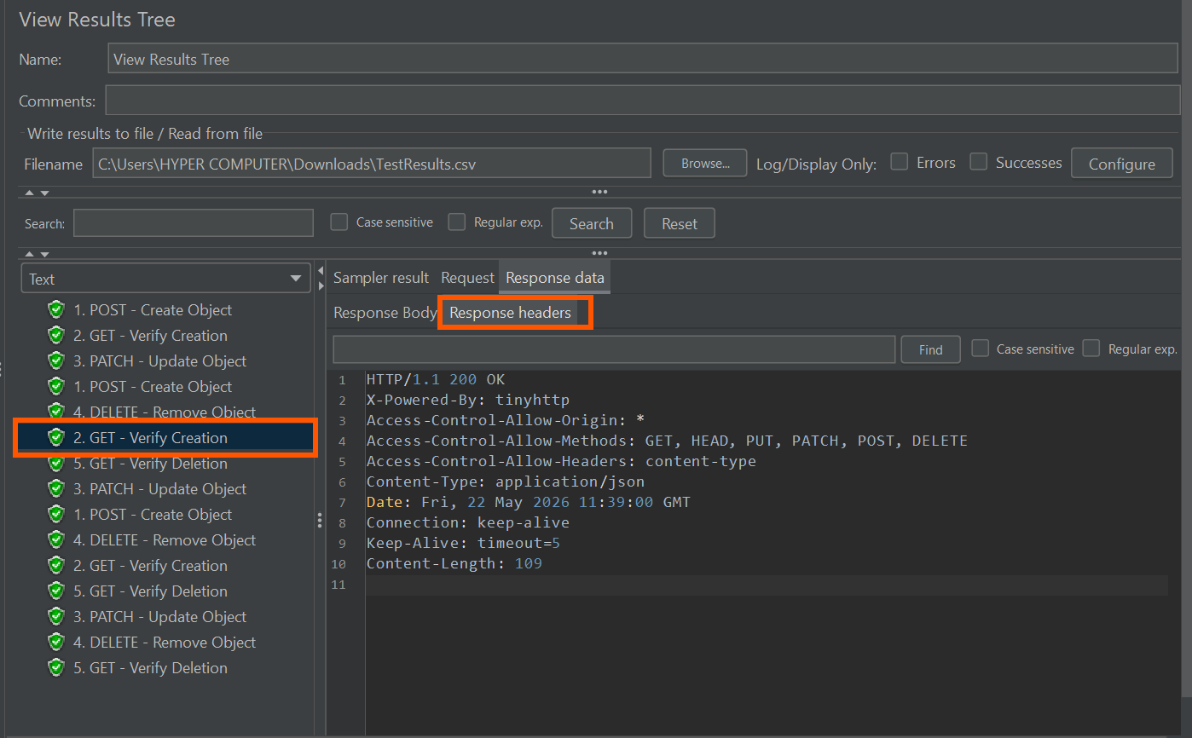

Step 3.3: PATCH - Update Object
Objective: Perform a partial update on the newly created object to verify the database's mutation capabilities.
Execution: The payload was modified to append '- QA UPDATED' to the product title. Asserts a 200 OK status code.

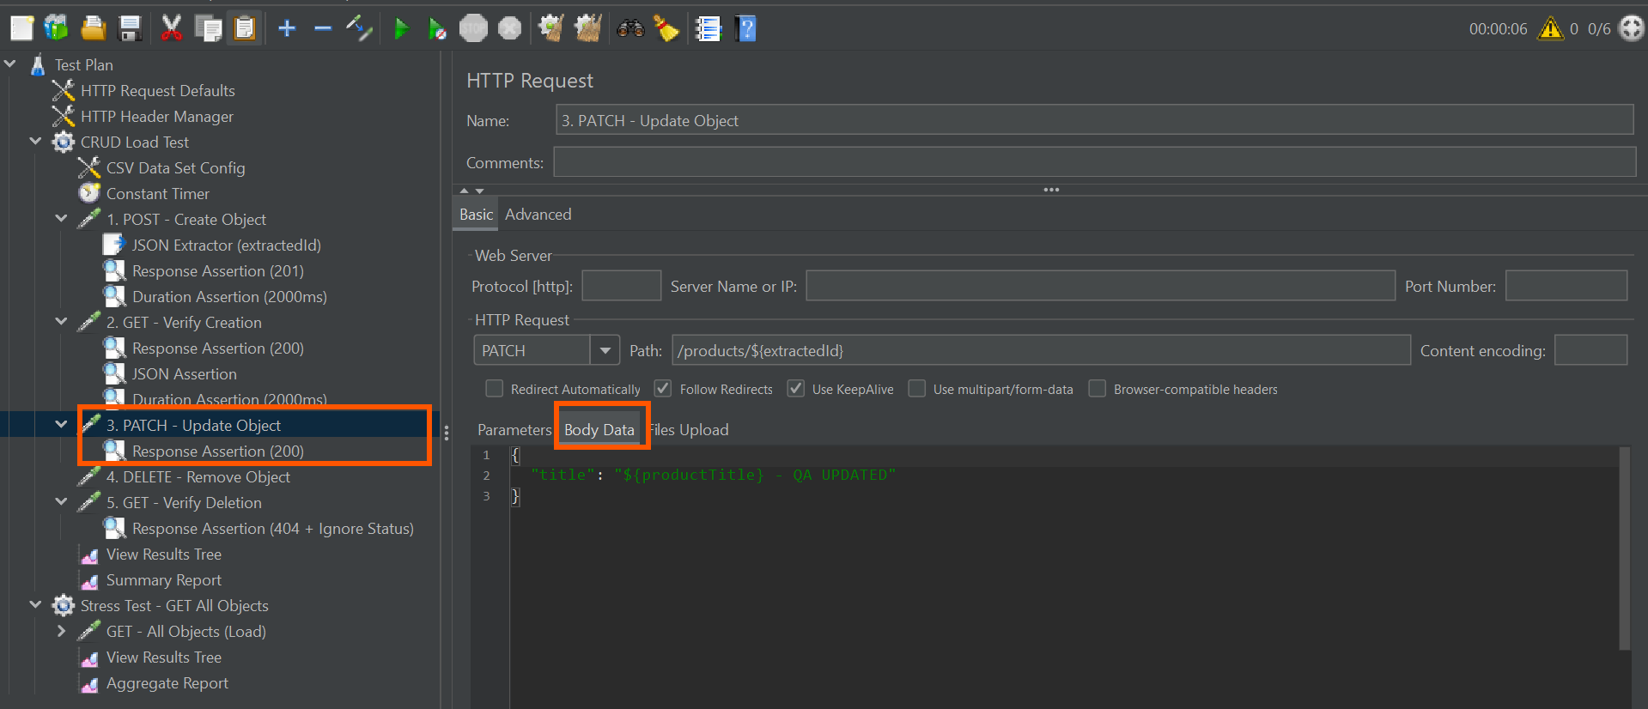

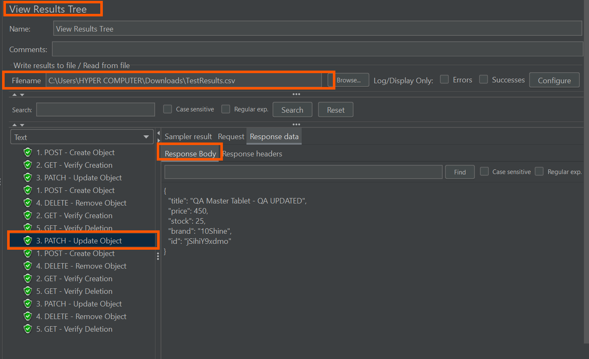

Step 3.4: DELETE - Remove Object
Objective: Execute the deletion command for the chained ${extractedId} to maintain database hygiene.
Assertion Logic: Asserts a 200 OK status code to confirm the server accepted and processed the deletion command.

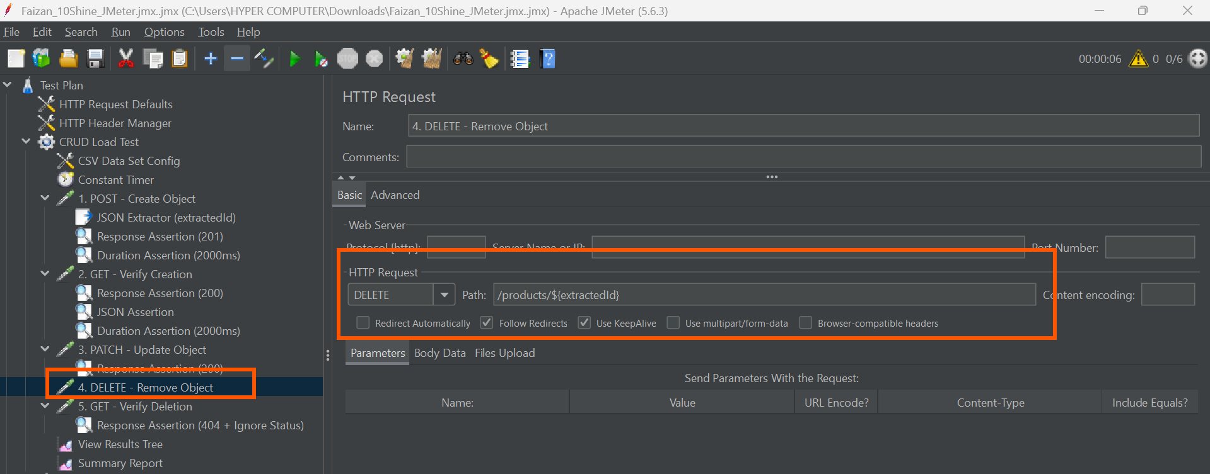

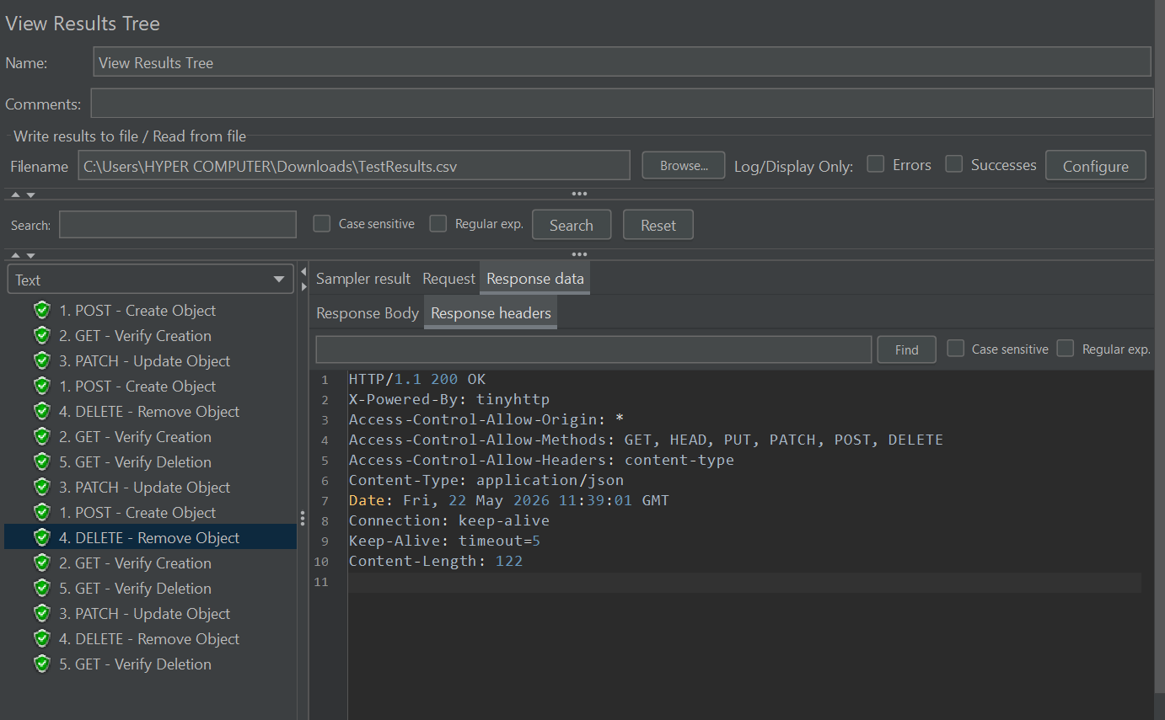

Step 3.5: GET - Verify Deletion (Negative Testing)
Objective: Prove that the object no longer exists in the system.
Assertion Logic: This step intentionally attempts to fetch the deleted ID. A custom Response Assertion was configured to expect a '404 Not Found' error. The 'Ignore Status' flag was checked, instructing JMeter to mark the test as PASSED when the 404 is successfully triggered.

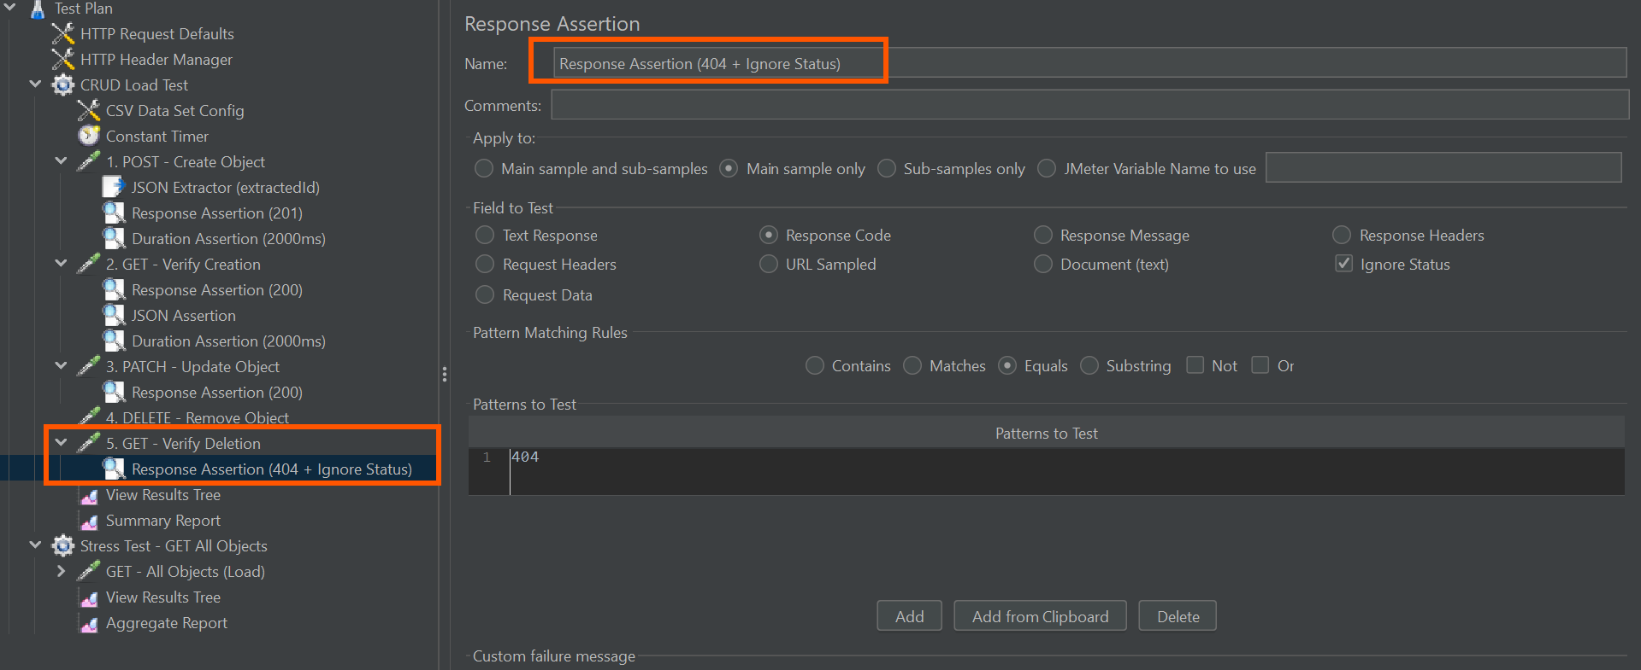

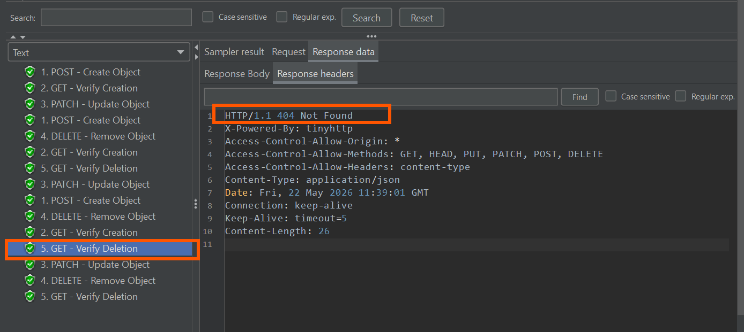

Results

Results Tree:

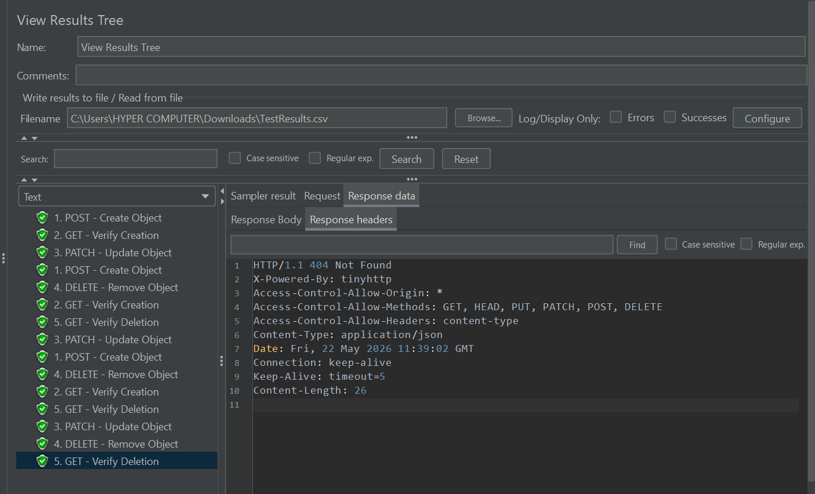

Summary Report:

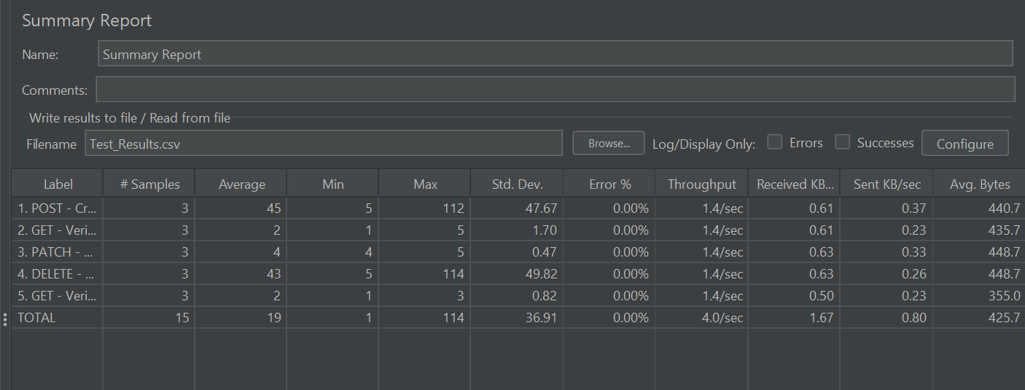

4. Performance Engineering & Stress Testing
To simulate real-world traffic, a secondary Thread Group ('Stress Test - GET All Objects') was configured to execute following the successful completion of the CRUD cycle.

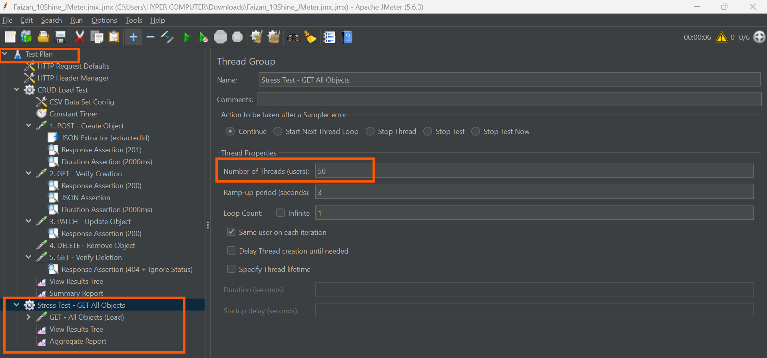

Stress Test Parameters:
- Target Endpoint: GET /products
- SLA Assertion: A Strict Duration Assertion was implemented to ensure the system responded within acceptable latency thresholds under load.
- Concurrency: Deployed a swarm of virtual users to generate high-volume throughput without degrading the server's error rate.
The resulting Aggregate Report confirms zero degradation in system performance, maintaining a 0.00% error rate across all concurrent samples.

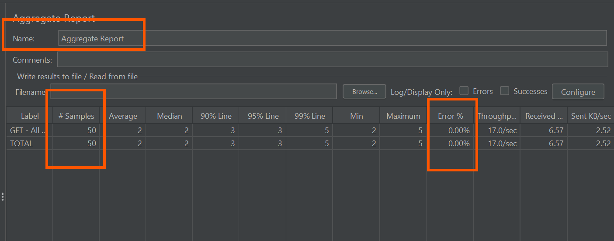

5. Technical Challenges & Resolution Strategy
During the execution of this assignment, several real-world performance testing hurdles were encountered and systematically resolved:

1. HTTP 429 Rate Limiting (Public APIs):
Initial testing against restful-api.dev resulted in a rapid '429 Too Many Requests' block due to strict public IP rate limits. Attempts to bypass this using cellular hotspots and VPNs proved unstable for sustained load testing.
2. Mock-API Limitations (DummyJSON):
A pivot was made to DummyJSON; however, as a mock API, it generated a '201 Created' status without committing the data to a backend. This inherently broke the API Chain, as downstream GET requests returned 404s for data that was never truly saved.
3. The Local DevOps Resolution (JSON Server):
To achieve a pristine, uncapped testing environment, a 'JSON Server' was deployed locally via Node.js. This provided a true REST architecture that physically wrote data to a local db.json file. This localized deployment allowed for unlimited, high-velocity stress testing and verified the absolute validity of the API Chaining logic.

